

Travlr Getaways Booking

# **CS 465 Project Software Design Document**

Version 1.2

## Table of Contents

**CS 465 Project Software Design Document** 1

Table of Contents 2

Document Revision History 2

Instructions 2

Executive Summary 3

Design Constraints 4

System Architecture View 5

Component Diagram 5

Sequence Diagram 7

Class Diagram 9

In the above class diagram, we see we have 12 JavaScript classes, and they are as follows: 9

API Endpoints 11

The User Interface 12

References 21

## Document Revision History

| Version | Date | Author | Comments |
| --- | --- | --- | --- |
| 1.0 | 07/21/04 | Justin Starr | Updated Executive Summary, Design Constraints, and System Architecture View |
| 1.1 | 8/4/2024 | Justin Starr | Updated Document Version, Sequence Diagram, Class Diagram, and API Endpoints |
| 1.2 | 8/18/2024 | Justin Starr | Updates Sequence Diagram, API Endpoints, and User Interface |

## Instructions

Fill in all bracketed information on page one (the cover page), in the Document Revision History table, and below each header. Under each header, remove the bracketed prompt and write your own paragraph response covering the indicated information.

## Executive Summary

The architecture of the web application that will be developed for the client Travelr Getaways is a full-stack web application consisting of a customer-facing website, a database, and an administrative single-page application (SPA) that will all work together. To achieve this, a combination of technologies, called a MEAN stack will be implemented to create a database and web server that will operate on the back end, contain application logic and control in the middle of the stack, and will go all the way to the front end with a user interface (Harber & Holmes, 2019).

The MEAN stack is a complete JavaScript stack that is comprised of four main technologies, allowing for the creation and deployment of dynamic web applications. The M in MEAN stands for MongoDB, which is the database, the E stands for Express, which is the web framework, the A stands for Angular, which is used for the front-end framework, and the N stands for Node.js, which is used for the web server.

MongoDB is a NoSQL database that allows the storing of data in JSON-like documents, making it more flexible, and it provides easy scalability for web applications as well as high performance (Eddie, 2022).

Express is the server framework that can serve static HTML content and support using JavaScript to code the necessary logic and behaviors required to meet the client requirements. It is a lightweight framework that provides an easy-to-use interface, which connects NodeJS with MongoDB, allowing you to use RESTful routes that directly connect HTML content to data in the application's database (Eddie, 2022).

AngularJS is used to develop single-page applications, which in the case of this application will be used for the administrative page. Typically, a MEAN stack application’s architecture includes a representational state transfer (REST) API that feeds the single-page application (Harber & Holmes, 2019). It essentially creates a stateless interface to the database that enables applications, such as Angular SPA to work with the data, and it uses JSON throughout the stack, including in the database (Harber & Holmes, 2019).

NodeJS is a platform that is event-driven and it is a non-blocking input/output model, which keeps it lightweight and efficient (Eddie, 2022). This means that it can handle multiple requests at the same time without blocking other code execution (Ramos, 2023).

Express and Node.js work in conjunction with each other to deliver HTML content directly from the server to the client-facing side of the application, which can also be done using templates, such as handlebars. The administrative single-page application will be implemented with Angular on the front end. Using a REST API that is built using Express and Node.js, content can be routed to both the client-facing side of the application and the Angular single-page application. Changes made from the administrative side can be seen on the customer-facing side almost immediately after making any changes.

## Design Constraints

It is essential to consider that while developing the Travelr Getaways Booking application there are design constraints. For example, JavaScript applications are difficult to crawl and index, and search engines, while they look at HTML content on a page, they do not execute or download much JavaScript (Harber & Holmes, 2019). Therefore, it can not be determined precisely how much of the content will be indexed if all of the content is served via a JavaScript application (Harber & Holmes, 2019). A similar issue exists is that automatic previews from social-sharing sites do not work well, similarly because they look at the HTML of the page you are trying to link, where the social-sharing sites attempt to extract some relevant text and images. Just like the search engine problem, they do not run JavaScript on the page, and therefore any JavaScript content that is served up will not be seen (Harber & Holmes, 2019). There are workarounds for these problems, however, they require a large amount of effort, and maintaining them can become problematic (Harber & Holmes, 2019). These concerns are significant because the type of application that is being built would benefit from the exposure that can be gained from social media sharing and search engine traffic. The more people that can either find the web application or hear about it from other people, the better the business will likely grow.

Additionally, another consideration is that SPAs have a slower first-page load than server-based applications. (Harber & Holmes, 2019). This is because SPAs have to bring down the framework and application code before the required view can be rendered in the browser as HTML, whereas server-based applications only have to push the required HTML (Harber & Holmes, 2019). However, based on the size of the client’s application that is being built, this for the time being, should not be much of a problem.

Another consideration of the design is the database itself. Earlier versions of MongoDB do not support ACID transactions, which could result in the loss of data if while processing multiple requests, the application becomes unstable (Eddie, 2022). However, MongoDB version 4.0 began supporting ACID transactions which help to ensure database transactions are processed in a reliable way.

Lastly, implementing a MEAN stack architecture can have drawbacks such as performance issues. Node.js executes JavaScript code one task at a time, unlike how it handles other tasks. While this single-threaded approach does have its advantages, it could potentially lead to bottlenecking during CPU-intensive tasks (Ramos, 2023).

## System Architecture View

### Component Diagram

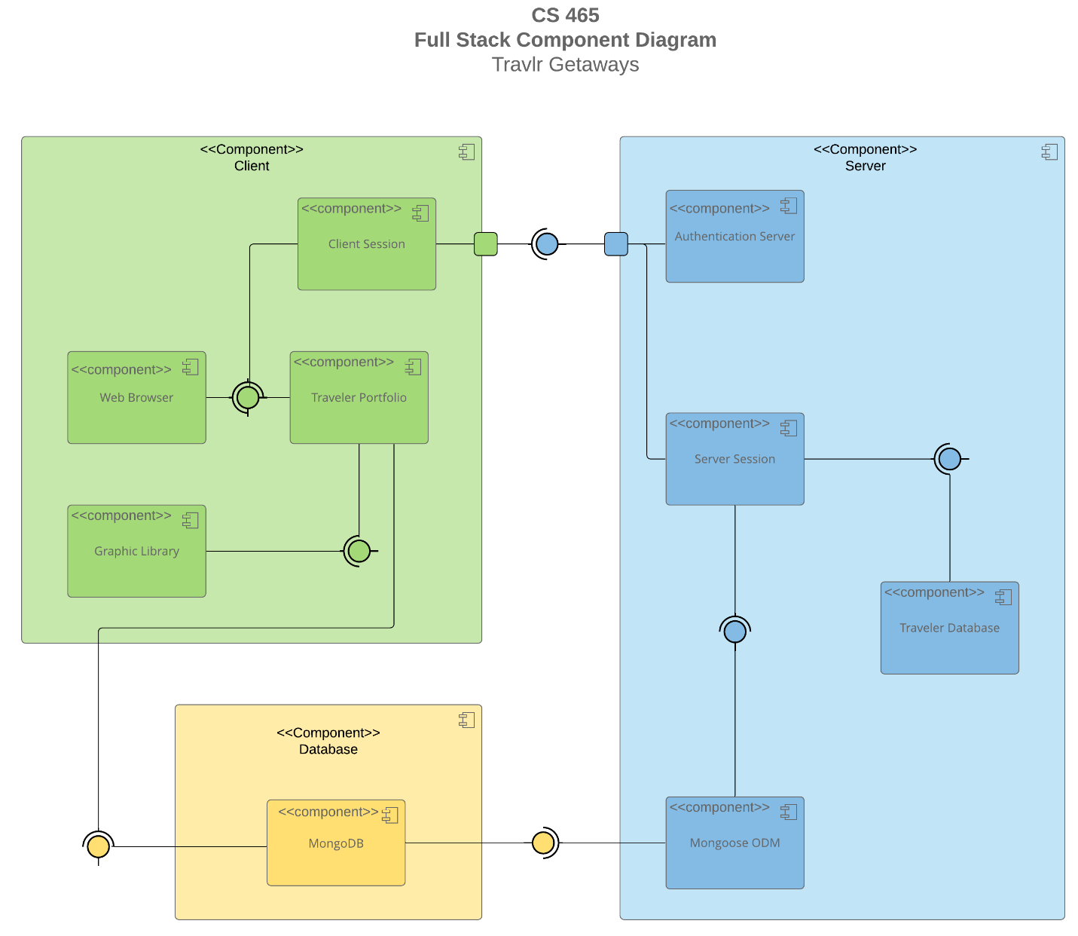

A text version of the component diagram is available: [CS 465 Full Stack Component Diagram Text Version](https://learn.snhu.edu/d2l/lor/viewer/view.d2l?ou=6606&loIdentId=24342).

As seen in the above component diagram, we have three main components, which are the Client, Server, and Database components. Within these three components contain sub-components that are responsible for one clear aim, and on a need-to-know basis, only interact with other essential elements (Visual Paradigm, 2024). Each component can be recognized by the component icon located in the top right corner of every component rectangle.

The colored circles with half circles around them represent interfaces that indicate that they are either required by one component or provided by a component. The direction for which that half circle around the interface indicates that it is pointing to the required interface, and the other component that the interface connects to is the provided component. Therefore, we can see that the Client component requires the Server component, and therefore, the Server component is provided to the Client component. Also, we see that both the Client and Server components require the Database component, and the Database component is provided to both the Client and Server components.

Both the Client and Server components contain a port, represented using a square placed on the side or edge of both components. They are used to “help expose required and provided interfaces of a component” (Visual Paradigm, 2024).

Lines are used to connect components to interfaces that then connect to another component. Because these types of lines do not have arrows on either end of them, this means that they demonstrate an association between connected interfaces/components. By understanding what components are associated with other components, and knowing whether or not a component is required of or provided to another component, we gain a better understanding of the system and the relationship between components.

Beginning with the Client component, there is a Traveler Portfolio component that is required by the Web Browser component, which is the user interface. Both of these components are required by the Client Session component. The Graphics Library component requires the Traveler Portfolio component, and the Traveler Portfolio component requires the Database component.

The Client Component requires the Server component, however it is not the case that the Server component requires the Client component. A user is able to be directed to the Authentication Server component, where if authenticated, a Server Session is established.

The Server Session Component allows the authenticated user to manage the Traveler Database and update the Database component. The Server Session component requires the Traveler Database and Mongoose ODM Component, and the Mongoose ODM component requires the MongoDB component. The Mongoose ODM (Object Data Modeling) is a library “for MongoDB and Node.js. It manages relationships between data, provides schema validation, and is used to translate between objects in code and the representation of those objects in MongoDB” (Hossen, 2022).

### Sequence Diagram

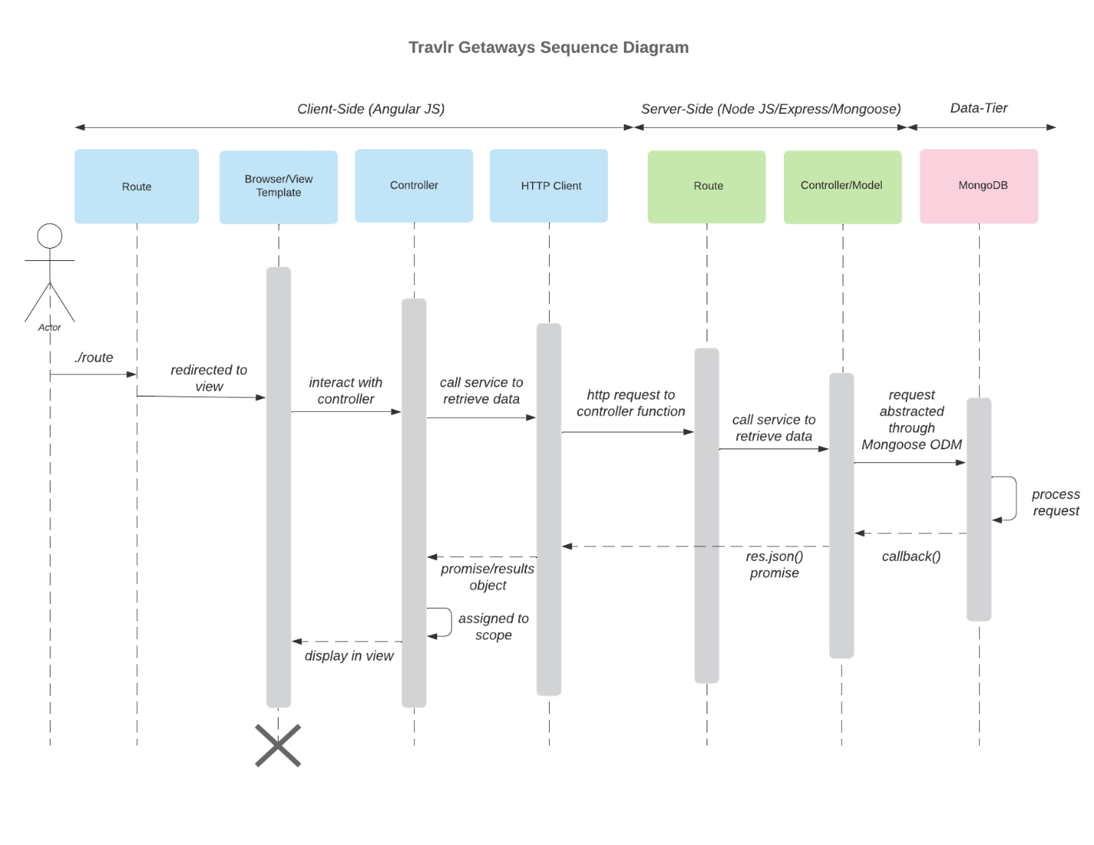

First, we see that the front-end (Client-Side) is built using Angular JS, and the back-end (Server-Side) is built using Node JS, Express, and Mongoose. The database also exists on the server-side, which is implemented and maintained through MongoDB.

The process or sequence begins with the actor who is the user. The user navigates to a specific path in their web-browser where the application checks that the path is valid. The route redirects the user to the appropriate view for the specified route, it gathers the view data, where it then interacts with the appropriate controller. The controller makes a call to retrieve the data for the route. If the route has an api endpoint, then the HHTP client sends a request to the server controller which it is routed to by the server’s routes. The server's routes find the appropriate controller for the specified api endpoint, where the request is then abstracted through the mongoose ODM (Object Data Modeling). This allows us to work with the data in the application using JavaScript, and it provides easy communication between the application and the database. The request is processed and returns the requested data specific to each endpoint. One endpoint might be requesting all documents, or another may request a specific document. The callback function is then called and response is returned to the HTTP Client in JSON format, which allows the data to be easily read. The controller on the client-side is awaiting the request to be returned. Once the controller has received the results object, it assigns it to the scope and renders the appropriate view in the browser.

One example of a process that can be referenced with the above sequence diagram is the process for trips interaction. The following is a description of this interaction based on the sequence diagram.

For the trips interaction, a user could navigate to the trips endpoint by typing in the address of the api endpoint “localhost:3000/api/trips”. The request begins by being routed to the apiRouter where it will then interact with the tripsController. Based on the specific “/trips” route, the tripsController calls the appropriate function, in this case tripsList, to make a request for all records from the trips collection in the travlr database located on the server. This request is abstracted through the Mongoose ODM, the database processes the request, and the callback() function from the controller waits for the request to be processed. The response is received and the data is sent back to the client. Then, the results object is processed by the controller and returned to be displayed in the browser.

The sign-in or log-in interaction is used in the SPA and a user can navigate to the login endpoint by typing in the address of the API endpoint: “localhost:4200/login” or by navigating to the SPA by typing “localhost:4200” and then clicking the log-in button in the top right corner of the page. The request begins by being routed to the apiRouter where it will then interact with the authController by specifically calling the login function. It then makes a request to verify that the email and password submitted by the user matches an existing record in the user's collection in the database located on the server. This request is abstracted through the Mongoose ODM, the database processes the request, and the callback() function from the controller waits for the request to be processed. The response is received and if the user is returned as an object, a JWT token is generated that will allow the user to access administrative features. The JWT token is returned to the client, and the results object is processed by the controller to verify the JWT. Once the token is verified the SPA updates the view with the appropriate changes, changing the log-in link to log-out, and the administrative action buttons become visible (add-trip, edit-trip, and delete-trip components).

Once a user is logged in, they are able to see the administrative components on the screen. These components include the add-trip component, edit-trip component, and delete-trip component.

One example of an admin interaction is the add-trip interaction. When the add-trip button is clicked, the request begins by being routed to the add-trip component via the application router. The view (add-trip form) is rendered, and the user completes the required fields for adding a new trip. When the Save button is pressed, the add-trip component verifies that all fields have been validated, and then if the form is valid, the addTrip function is called in one of the applications services, trip-data.service. Trip-data.service then makes the appropriate api call for adding a trip, passing along with it the form data. This request is then abstracted through the Mongooose ODM, the database processes the request, and the callback() function from the controller then waits for the request to be processed. The response is received and the data is sent back to the client. Then the results object is processed by the controller and returned to be displayed in the browser. This process is nearly identical to the edit-trip and delete-trip components.

Once a user logs out, these components are no longer available to them.

## Class Diagram

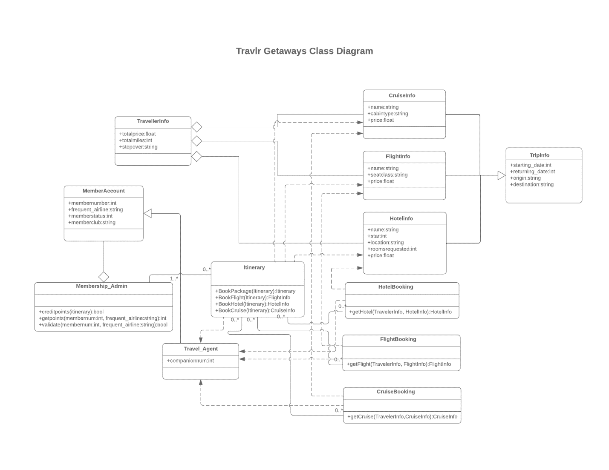  
First, it is essential to have an understanding of what the different symbols and arrows mean. An arrow with a closed head that is unshaded means that one or more classes inherit from the class that the arrow is pointing to. A line with an unshaded diamond at the end of it means that the class with the diamond end is an aggregate class. This means that it specifies a whole and its parts, and the class with diamond can exist without the class or classes that it has a relationship with. Lines with no arrows indicate that the two classes have an association, and lines with a solid arrow indicate that one class is dependent upon another.

## In the above class diagram, we see we have 12 JavaScript classes, and they are as follows:

TripInfo class:

In the TripInfo class, we have four public attributes, and this class is the parent class for CruiseInfo, FlightInfo, and the HotelInfo classes. When any of these three class are instantiated, they will inherit the four attributes from the TripInfo class. This class has no methods.

CruiseInfo class:

CruiseInfo has three public attributes and inherits from Tripinfo. It has an aggregate relationship with the TravelerInfo class, meaning TravellerInfo can exist outside or without the CruiseInfo class. We also see that the Itinerary and CruiseBooking classes both point to the CruiseInfo class. This means that both of those classes are aware of the CruiseInfo class and interact with it. This class has no methods.

FlightInfo class:

This class is similar to the Cruiseinfo class. It has three public attributes and inherits from the TripInfo class. TravellerInfo is also an aggregate class of the FlightInfo class, meaning it can exist without or outside the FlightInfo class. The itinerary and FlightBooking classes also are aware of the FlightInfo class and interact with it. This class has no methods.

HotelInfo class:

The HotelInfo class is similar to the previous two classes, however this class has five public attributes, and it also inherits from TripInfo. TravellerInfo is an aggregate class of HotelInfo and can exist outside or without the Hotelinfo class. Both the Itinerary and HotelBooking class are aware of the HotelInfo class and interact with it. This class has no methods.

HotelBooking class:

The HotelBooking class has no class attributes and does not inherit from any other classes. The Itinerary class has a zero to many relationship with the Hotelbooking class. Also, the HotelBooking class is aware of the Travel_Agent class and interacts with it, and also has a zero to many relationship with it. HotelBooking has one public method. The method getHotel is public and interacts with the HotelInfo class.

FlightBooking class:

The FlightBooking class is similar to the HotelBooking class. It has no class attributes and does not inherit from any other class. The Itinerary class has a zero-to-many relationship with the FlightBooking class. The FlightBooking class is aware of the Travel_Agent class and interacts with it, and it also has a zero to many relationship with it. FlightBooking has one public method. This method, getFlight is aware of the FlightInfo class and interacts with it.

CruiseBooking class:

This class is also similar to the HotelBooking and FlightBooking class. It has no attributes and does not inherit from any other class. The Itinerary class has a zero-to-many relationship with the CruiseBooking class. The CruiseBooking class is aware of the Travel_Agent class and interacts with it, and it also has a zero to many relationship with it. CruiseBooking has one public method. This method, getCruise is aware of the Cruiseinfo class and interacts with it.

Itinerary class:

The Itinerary class has no attributes, and it does not inherit from any other classes. It has zero to many association with the Membership_Admin class. It is aware of and interacts the CruiseInfo, FlightInfo, and HotelInfo classes. It also has a zero to many association with the HotelBooking, FlightBooking, and CruiseBooking classes. The Itinerary class has four public methods: BookPackage, BookFlight, BookHotel, and BookCruise. BookFlight interacts with FlightInfo, BookHotel interacts with Hotelinfo, and BookCruise interacts with Cruiseinfo.

TravelerInfo class:

The TravellerInfo class has three public attributes and does not inherit from any other classes. It is aggregate to the CruiseInfo, FlightInfo, and Hotelinfo classes, meaning that it can exists outside or without any of these three classes. This class contains no methods.

MemberAccount class:

The MemberAccount class has four public attributes, and does not inherit from any other class, however the Travel_Agent class inherits from this class. The Membership_Admin class is aggregate to this class, meaning it can exist without this MemberAccount class. The MemeberAccount class has no methods.

Membership_Admin class:

The Membership_Admin class has no attributes and does not inherit from any other classes. This class is aggregate to the MemberAccount class, meaning it can exist without or outside of the MemberAccount class. It has a one to many relationship with the Itinerary class, and it contains three methods, creditpoints, getpoints, and validate.

Travel_Agent class:

The Travel_Agent class has one public attribute, and it inherits from the MemberAccount class. The Itinerary, HotelBooking, FlightBooking, and CruiseBooking classes have a zero to many relationship with this class, and all four classes are aware of and interact with the travel_Agent class.

## API Endpoints

| **Method** | **Purpose** | **URL** | **Notes** |
| --- | --- | --- | --- |
| **GET** | Retrieve list of trips | /api/trips | Returns all active trips |
| **GET** | Retrieve single trip | /api/trips/:tripCode | Returns single trip instance, identified by the tripCode passed on the request URL |
| **POST** | Retrieve JWT (Java Web Token) for user logging-in | /api/login | Returns JWT for the logged-in user |
| **POST** | Retrieve JWT (Java Web Token) for newly registered user | /api/register | Returns JWT for the newly registered user |

## The User Interface

Initial SPA screenshot (before logging in):

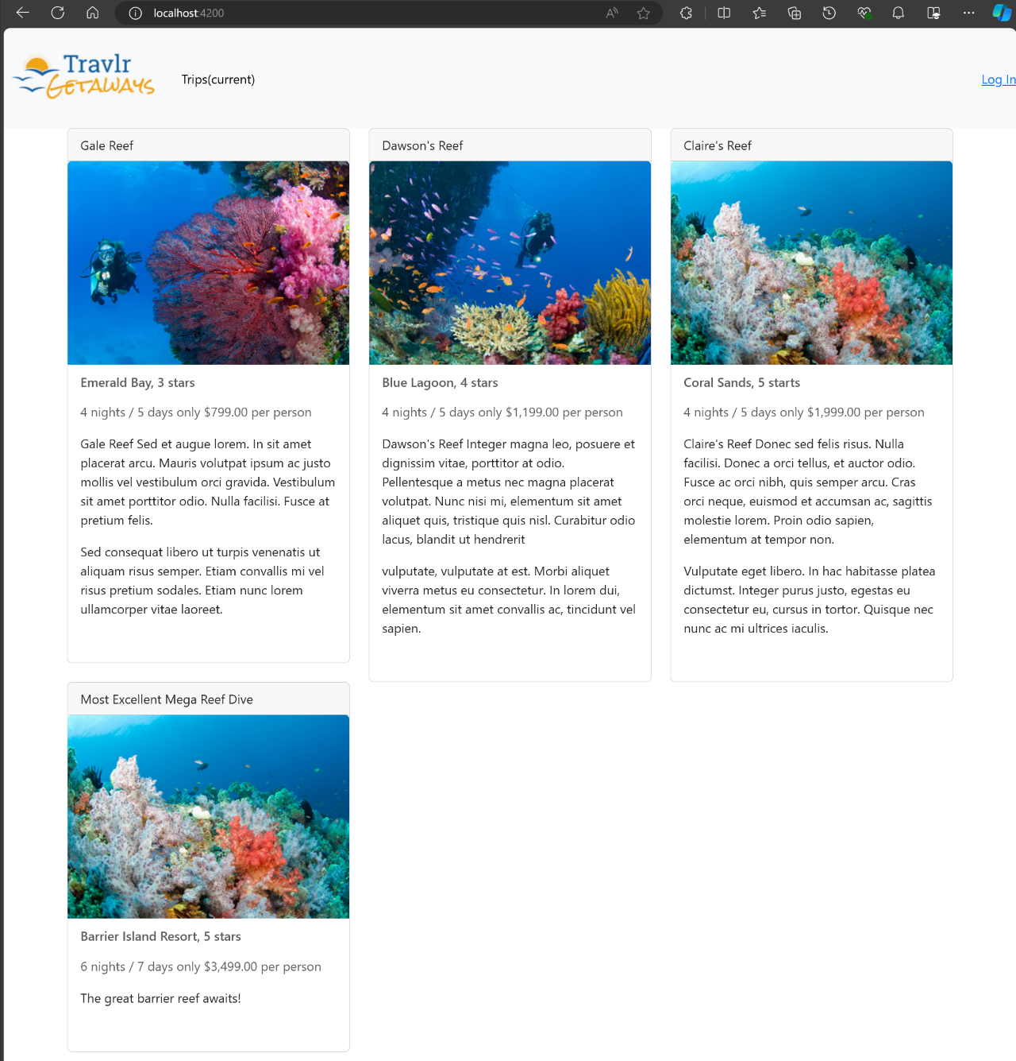

Login endpoint:

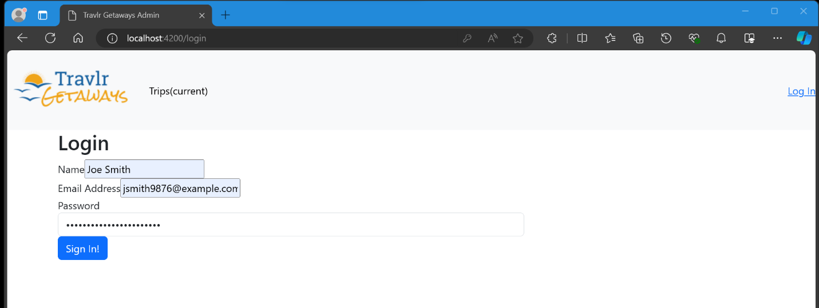

After logging in (admin features/buttons become available):

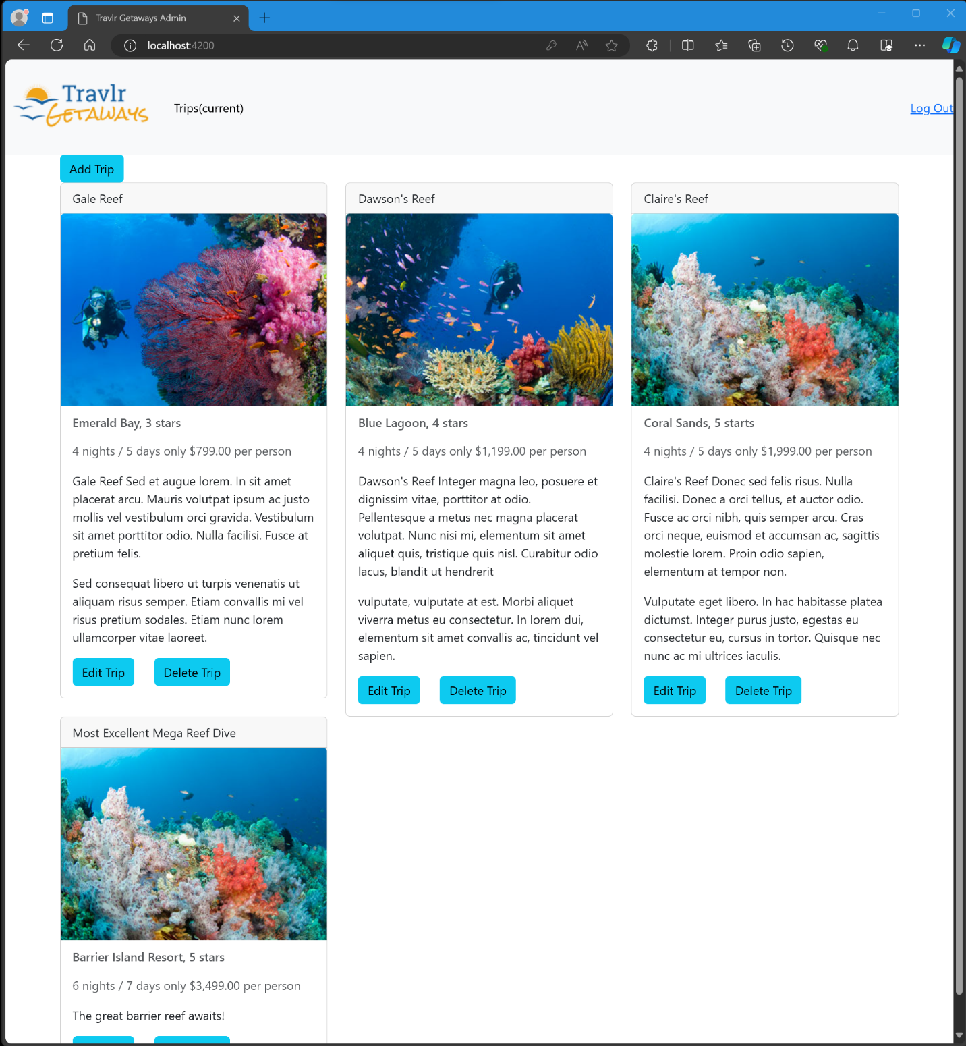

Add trip form:

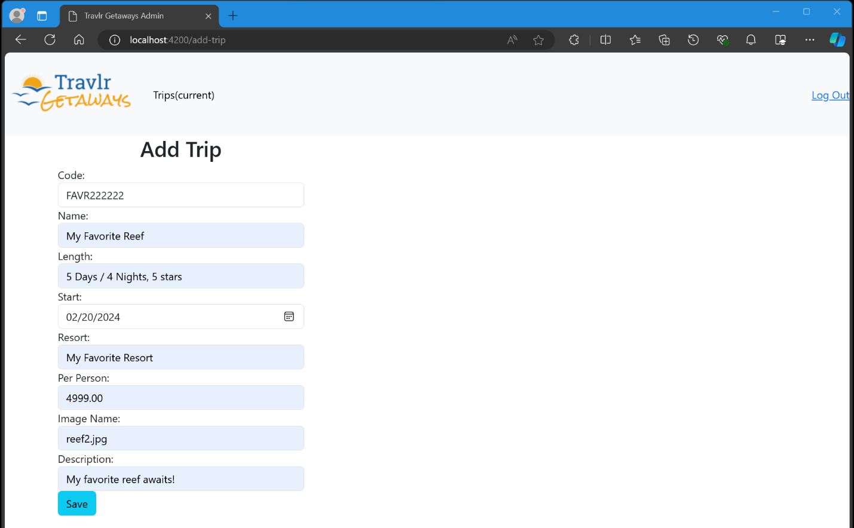

After adding a trip:

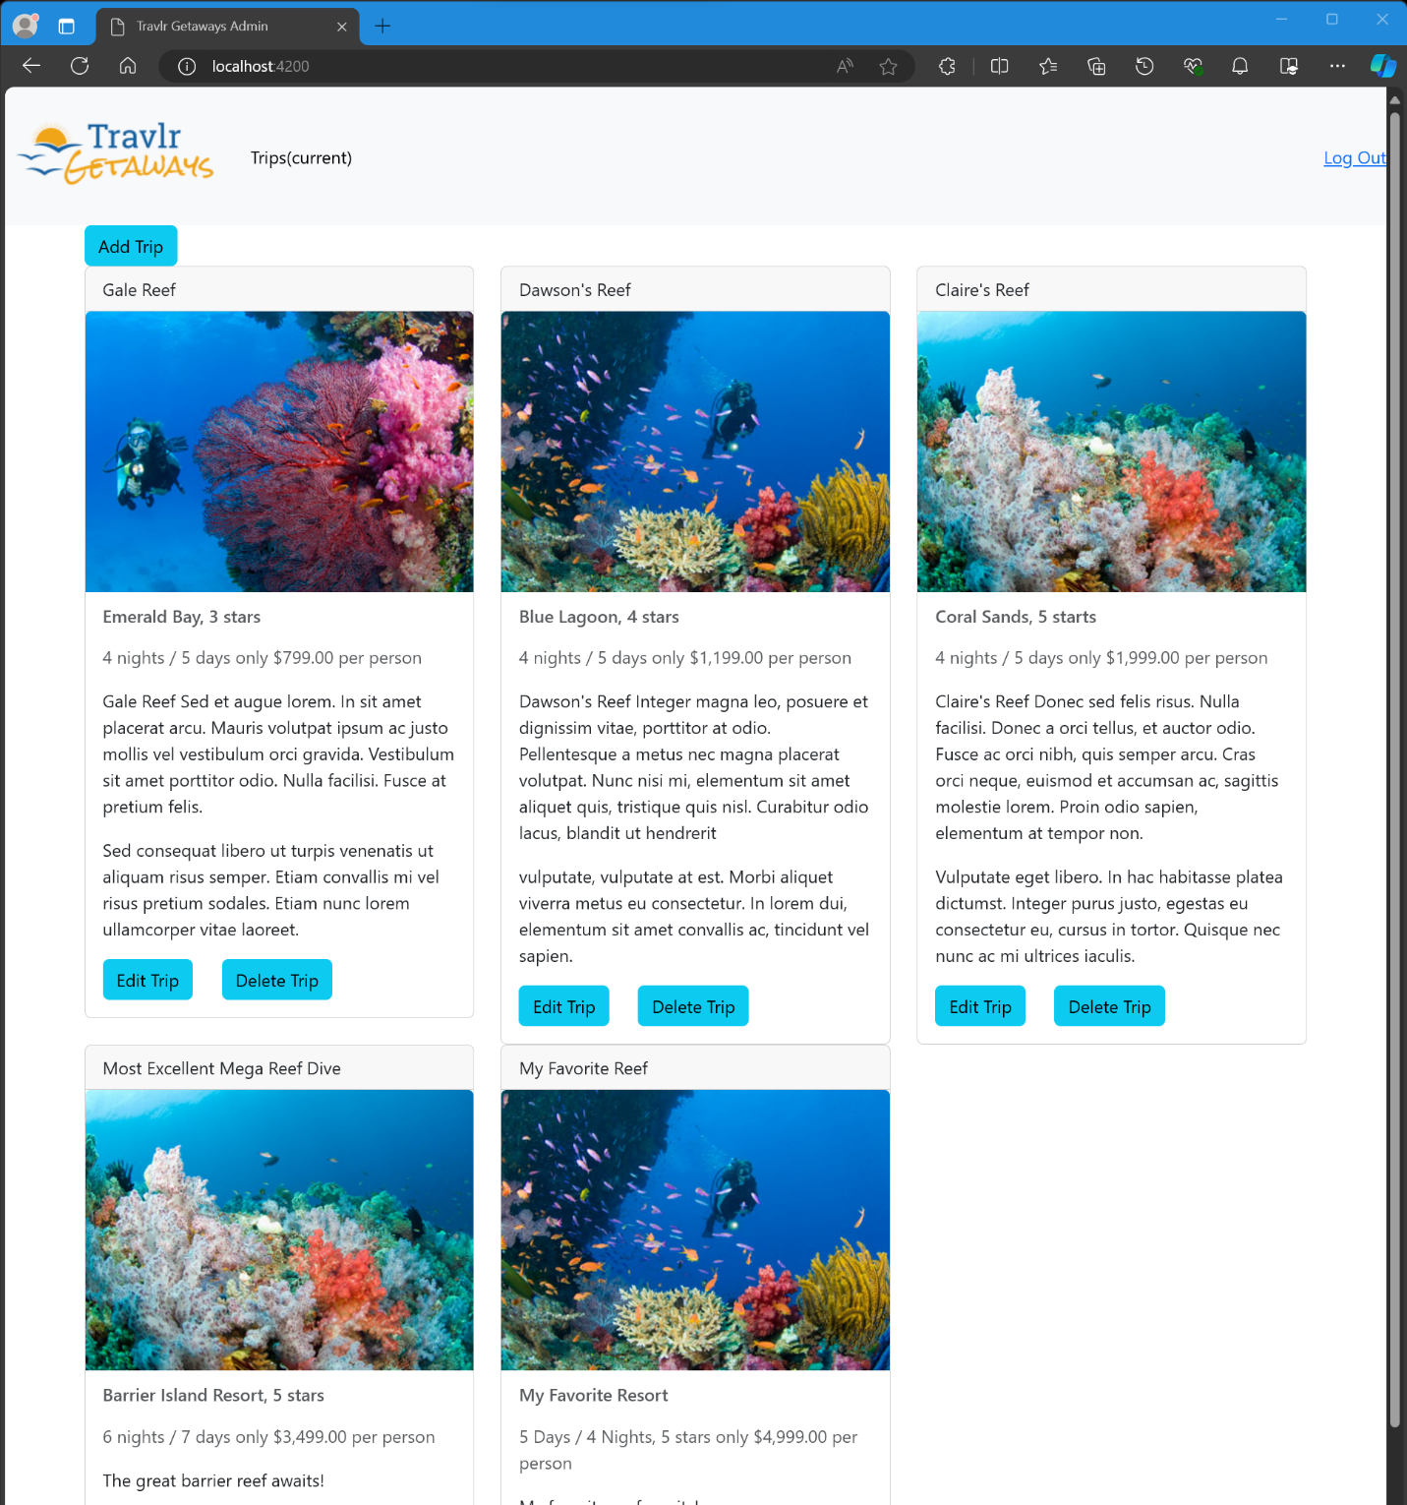

Editing the trip I added:

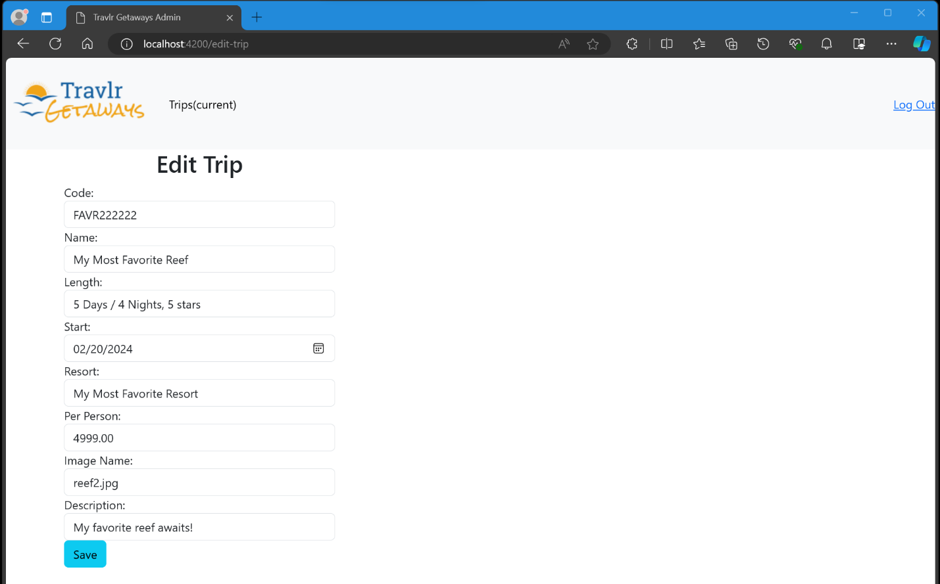

After editing the trip I added:

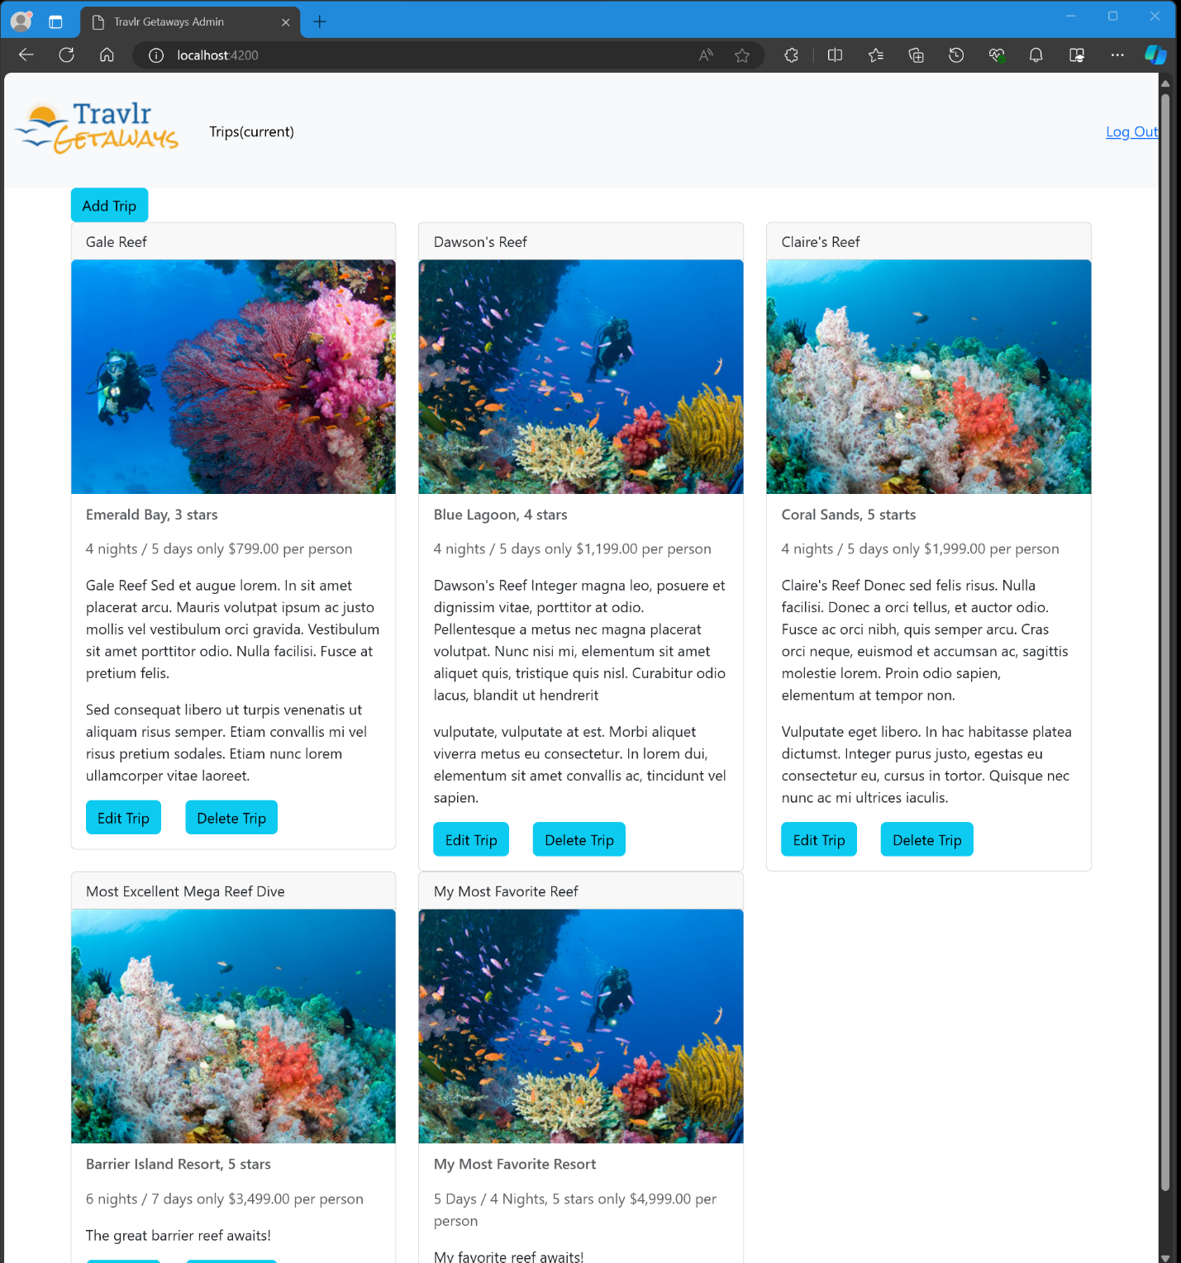

After Logging out (admin features/buttons become unavailable):

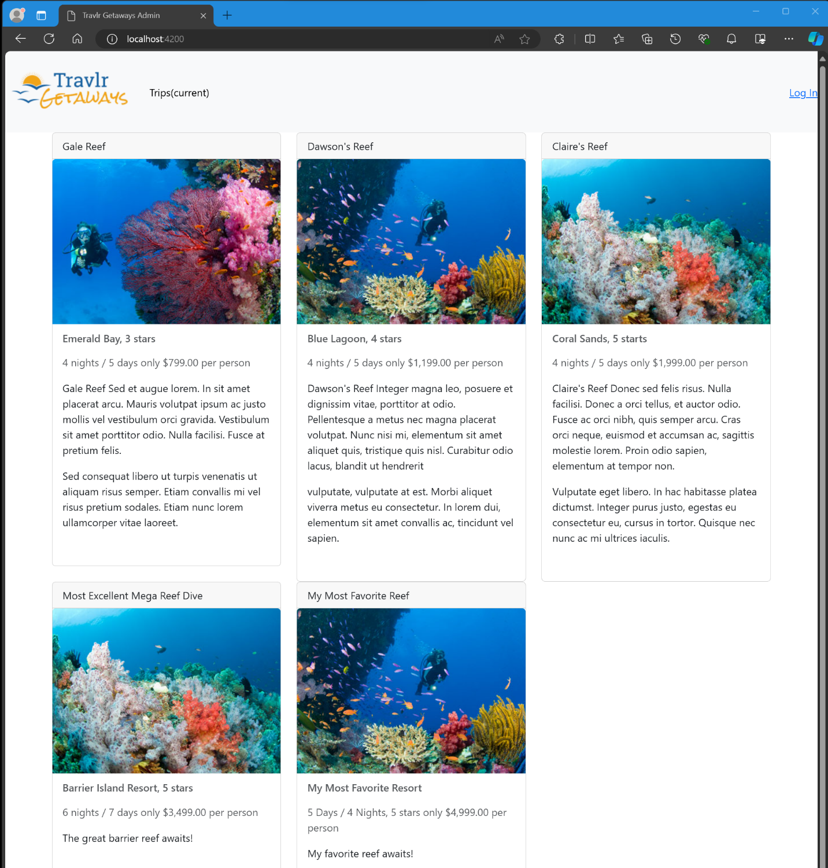

The angular project structure differs from that of the Express HTML customer-facing page, firstly because the customer-facing page uses a Model View Controller (MVC) design pattern to route user requests, retrieve the view for the specified route, and render data from the server database for each specific view. When using the Express application each user action triggers a full page reload. The Angular Single Page Application (SPA), uses components, services, and routes to load a single HTML page on the client-side, and it dynamically updates the content of the page as the user interacts with the application. This initial load only happens once, and the page simply updates as changes are made to any of the data. One key difference is that the Express application may contain several pages, whereas the SPA is what its name says, a single page. In an SPA, components are used to render various parts of the UI and help keep the application’s structure more organized. For example, in the SPA that was completed for our web application, a trip-listing component is used to render all of the trips in the database. Each trip retrieved from the database is displayed in a trip-card component, which displays all of the relevant trip information. Also, each trip-card component has an edit-trip, and delete-trip component that can be used to either edit the details of a trip or delete a trip entirely.

The advantages of using an SPA are that it has higher speed and efficiency than using a multi-page application where pages are reloaded every time a user makes a request. This leads to a better user experience because the user doesn’t have to constantly wait for page reloads, which occurs frequently in traditional or multi-page web applications (Vaishak, 2023). Additionally, using SPAs puts much of the burden of processing onto the client side rather than the server, which can lead to cost savings and enable the use of servers that are less powerful to handle application traffic (Vaishak, 2023). Also, SPAs offer cross-platform compatibility through the use of its JavaScript frameworks, enabling developers to create a single code base that can run on multiple platforms.

The disadvantages of SPAs are that there exist challenges with search engine optimization because the content is loaded dynamically via JavaScript, and search engines do not typically crawl JavaScript content. Placing the processing burden on the client side rather than on the server can cause the initial page load to take longer than most users expect a page to be loaded because initially, all of the application and its resources are loaded (Vaishak, 2023). Because SPAs use client-side routing, browser history, and bookmarks may not work as a user expects, depending on how the SPA is implemented. Lastly, SPAs can be more complex and challenging to implement compared to traditional websites, and if they are not properly secured, SPAs can be vulnerable to a number of security-related issues, such as Cross-Site Scripting (XSS) attacks (Vaishak, 2023). Overall, the additional functionality that is provided by an SPA compared to a simple web application interaction is a better user experience, faster load times, and a reduced server load.

One process of testing the SPA is working with the API to GET and PUT data in the database is by using a tool called Postman. With Postman, a user can set the query type PUT if the user wants to update a document in the database, or they can choose GET to have the database return either all documents in a collection or a specific document. After choosing the appropriate query type, we simply type in the url for the api endpoint and hit send, which bounces the request of the backend API endpoint. If everything is successful, a JSON object with the requested record(s) for the GET query will be returned, or in the case of the PUT query, a JSON object will be returned with the data of the document that is being updated in the database collection. Therefore, we can test by updating a document in the database collection using the PUT query and typing the appropriate URL for the API endpoint using the document ID that we want to update, and then use the GET query to retrieve a list of all documents showing that the updated document was updated successfully. While working with Postman, I did not experience any issues, however, I can see how it might be difficult to work with at first, especially if a user doesn’t understand how to use the queries correctly or how to interact with the different API endpoints.

## References

Eddie, J. (2022, January 7). *Why MEAN Stack is Best for Web*

*Development?* Medium. <https://enlear.academy/why-mean-stack-is-best-for-web-development-55b7e4a00d72>

Harber, C., & Holmes, S. (2019). *Getting MEAN with Mongo, Express, Angular, and Node, Second*

*Edition* (2nd ed.). Manning Publications.

<https://learning.oreilly.com/library/view/getting-mean-with/9781617294754/>

Hossen, I. (2022, March 4). *Mongoose*. DEV Community.

<https://dev.to/iftakher_hossen/introduction-to-mongoose-409g>

Ramos, M. (2023, September 11). *MEAN Stack Explained*. Kinsta.

<https://kinsta.com/blog/mean-stack/>

Vaishak (2023, November 1). *The Pros and Cons of Single-Page Applications*

*(SPAs)*. Medium. <https://medium.com/@VAISHAK_CP/the-pros-and-cons-of-single-page-applications-spas-06d8a662a149>

Visual Paradigm. (2024). *What is Component Diagram?* [https://www.visual-](https://www.visual-paradigm.com/guide/uml-unified-modeling-language/what-is-component-diagram/)

[paradigm.com/guide/uml-unified-modeling-language/what-is-component-diagram/](https://www.visual-paradigm.com/guide/uml-unified-modeling-language/what-is-component-diagram/)